District 123
Working With Canva Templates

Selecting Canva Templates
- Select the desired Canva link supplied in the Canva template list on the District 123 website, Public Relations page, www.toastmasters123.org/resources/publicrelations-newsletter-brand-library-canva-templates, under the Canva Templates section.
- Select the desired Canva template by clicking on the Canva link supplied.
- The Canva template will open in “View” mode.

Copy Template for Personal Use
- Click on "File" from the top menu to open the "File Menu".
- Click "Make A Copy" from the "File Menu".
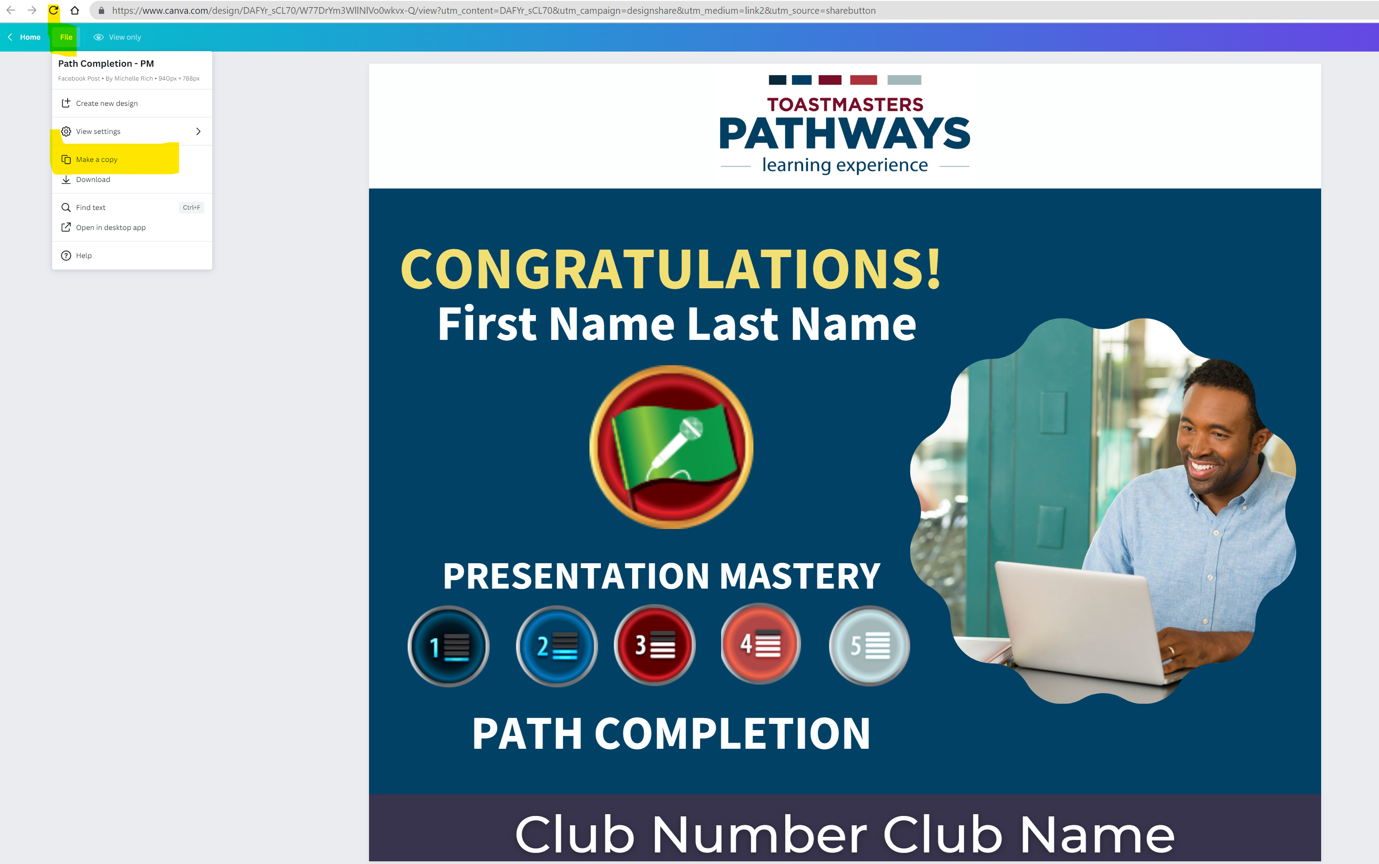
Edit Template for Personal Use
- Edit your copy with your own changes.

Download File For Use

- . To Download as .png or .jpg or .pdf, select "Share" from the top right-hand side of the Canva screen.
- . Select "Download".
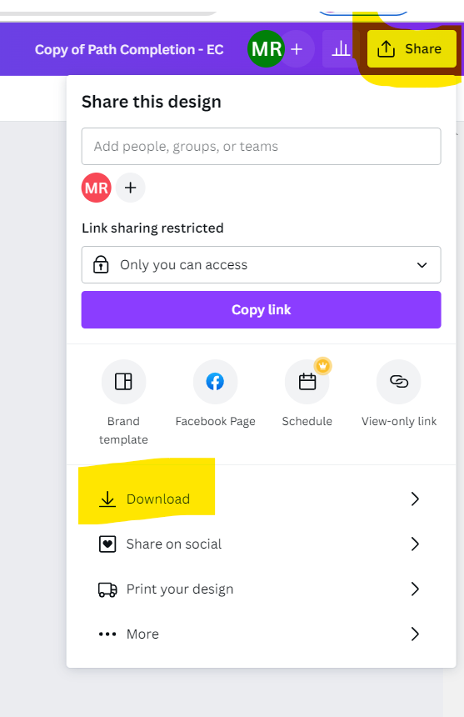

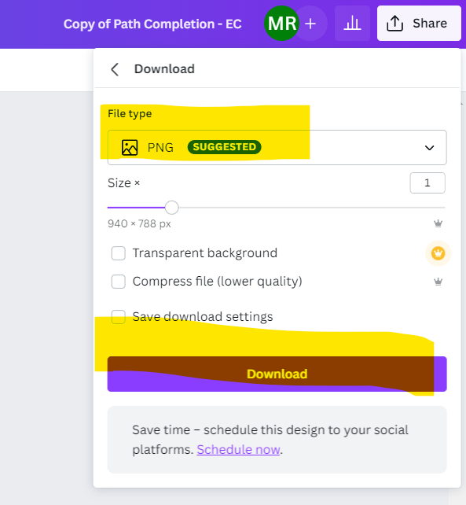
- Download File Type “.png” to post on Facebook, “.jpg” for other graphics uses,”PDF” for posters, anything you would print.
- Close window when finished with the file.
- Saving is automatic but for peace of mind or if you are faster than the automatic save, select “File” and “Save” to save your file.

